Coventry University

School of Computing, Engineering and Mathematics

**Report on the user experience design of the website**

**Student Name:** Wong Pak Kwan

**Student ID:** 247030520

VT6012CEM User Experience Design

**1 April 2025**

Content

1 Introduction 3

2 The scope and the goals of the redesign 4

2.1 The scope of the design 4

2.2 The goals of the design 9

3 Persona 10

4 Design principles 11

4.1 Visibility 11

4.2 Affordance 11

4.3 Feedback 11

4.4 Constraint 12

4.5 Consistency 12

4.6 Efficiency of the user (Tognazzini's Principle) 12

5 Prototype 13

5.1 Screen description and Screen flow 13

5.2 Prototype link 23

5.3 Demonstration 23

6 User evaluation 24

6.1 Ethical consideration 24

6.2 Practical consideration 26

6.3 Testing arrangement / method 26

6.4 Result 27

Reference 29

# 1 Introduction

Buymore.hk is an online platform specializing in computer hardware, offering a wide variety of computer hardware to meet the needs of users. From processors, graphics cards to whole computers. It even includes peripheral equipment and accessories such as live broadcast products, business software, printers, scanners, etc. At the same time, the website provides a variety of payment methods and ordering methods. Also, websites provide network configuration, cabling engineering, backup solutions, data recovery and other services. Both the service and product diversity are very good. So, the website provides a convenient shopping experience for users looking to upgrade or build their own computer.

Webpage Link: <http://buymore.hk>

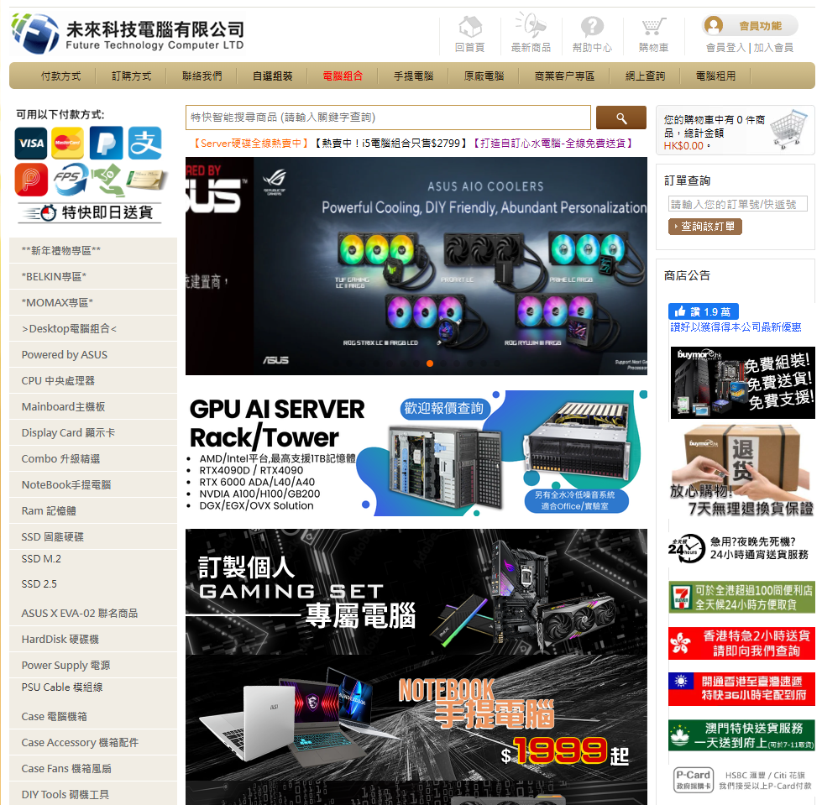

# 2 The scope and the goals of the redesign

# 2.1 The scope of the design

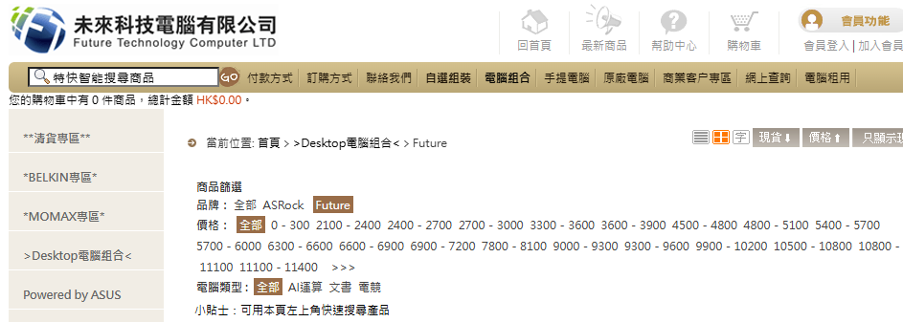

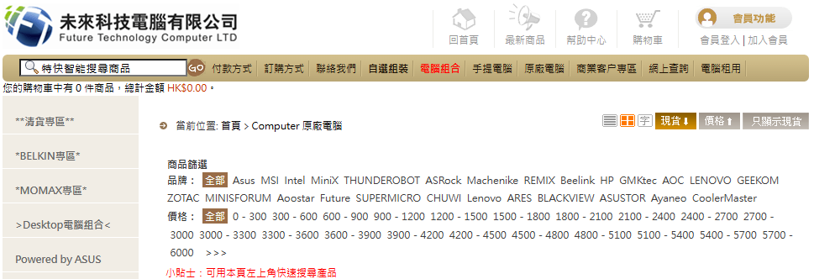

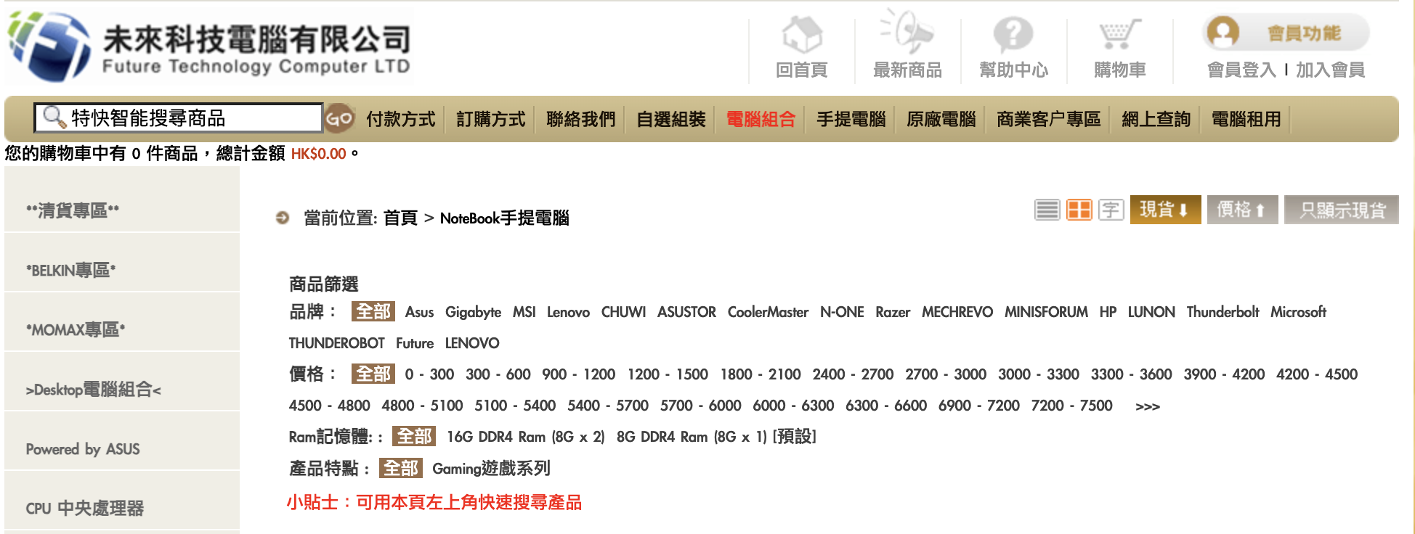

The price section and having some filter button of the Desktop Computer combination page, laptop page and original computer page. The User can filter and purchase the hardware product.

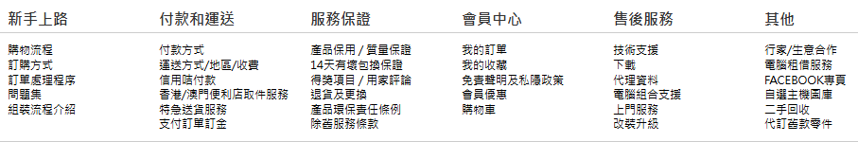

This part is on the bottom of any page. The User can click on the text to get the information or survey.

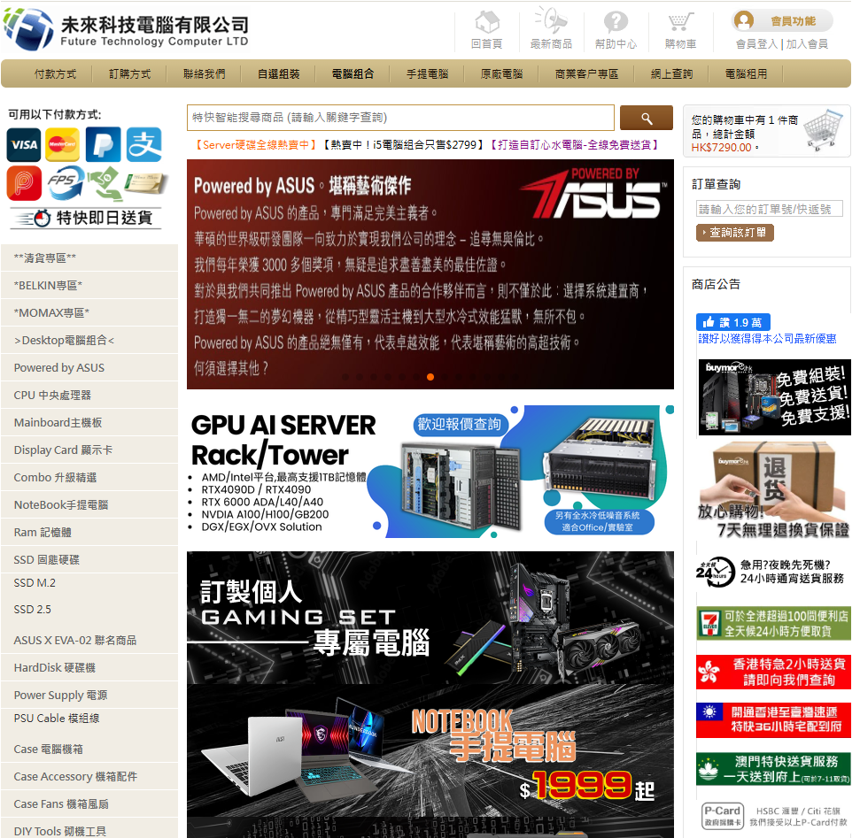

In the home page, the top of the bar. Users can click the button to complete the work.

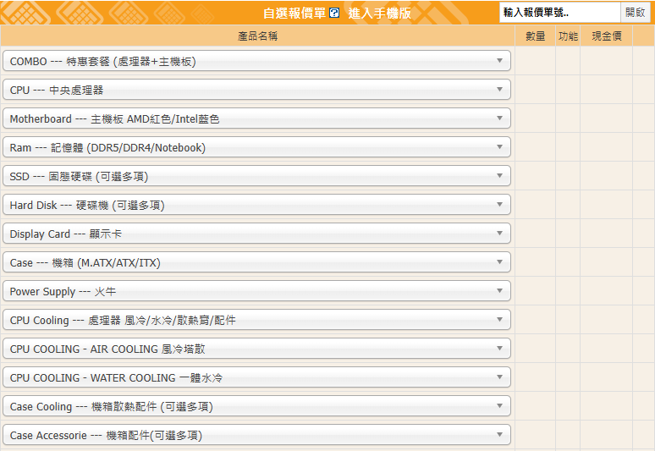

The drop-down menu in the self-selected quotation form. That makes the user choose the hardware combined. This part on the DIY(自選組裝) page

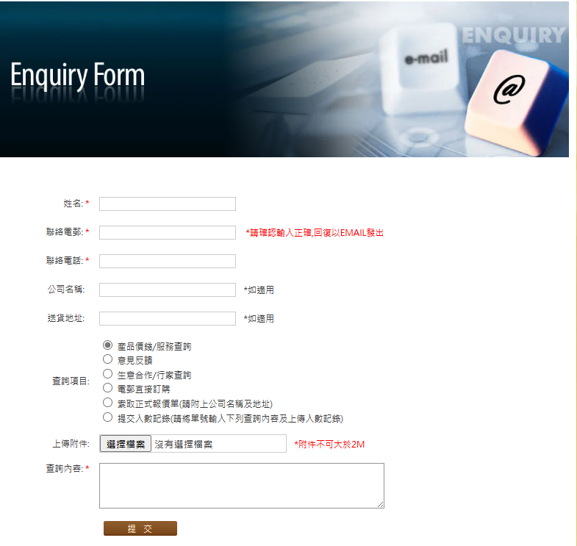

This part is on the online enquiry page, the customer can provide and submit feedback or questions to customer service.

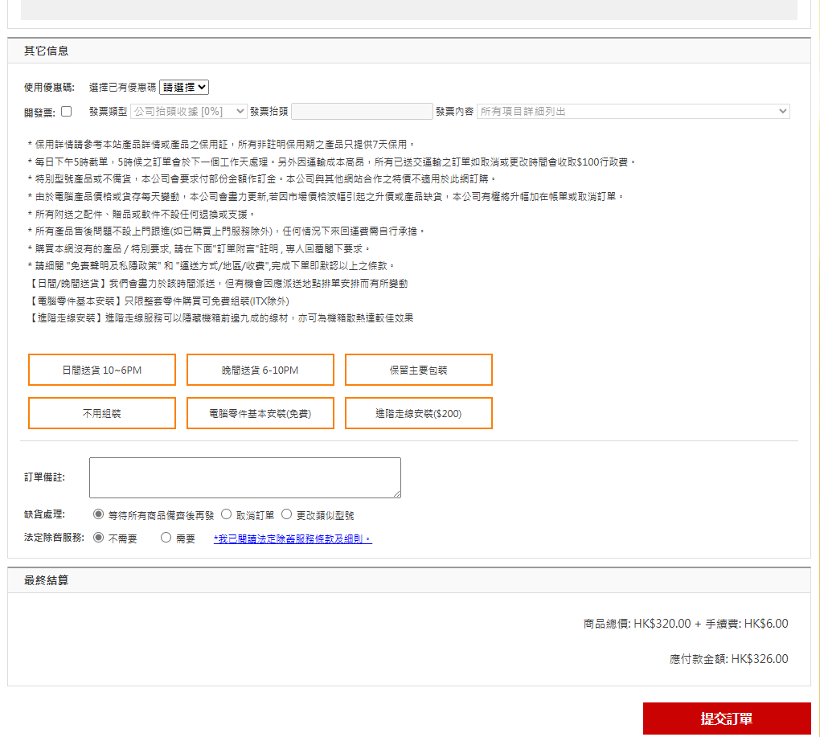

This page is on the purchase car page, to give the customer to submit the order.

# 2.2 The goals of the design

**Improve the “Efficient” of the buymore.hk website:**

The new design aims to facilitate easier interaction of the user with the site. Some of these will be the simplification of navigation so that the customer can find the product or service needed with less effort and the removal of unnecessary steps. Better filtering options, logical structure, and responsive design will make the search, comparison, and purchase less time consuming and less stressful.

**Enhance the “Utility and flexible” of the buymore.hk website:**

Utility is important to provide practical value or produce to users. Therefore, it should update unclear product descriptions or buttons. Products have more details and illustrations. So, customers would purchase what they want. Also, the website should increase more error control or reset control. So, users have flexible control.

**Improve the “Learnable” of the buymore.hk website:**

The interface is designed for simplicity of learning and usage for even the most inexperienced visitors. Tools like tutorials, a prominent "Getting Started" location, and easy-to-understand icons allow for better user understanding. The aim is to minimize the learning process as much as possible so users will be comfortable enough to navigate and make the most of the site for their services and shopping.

**Easy to Remember the buymore.hk website:**

Create a user-friendly and consistent interface with easy-to-remember usage of the site on future visits. Properly positioned buttons, common menu formats, and unique visual notifications make the user confident with the site even after some time has elapsed.

# 3 Persona

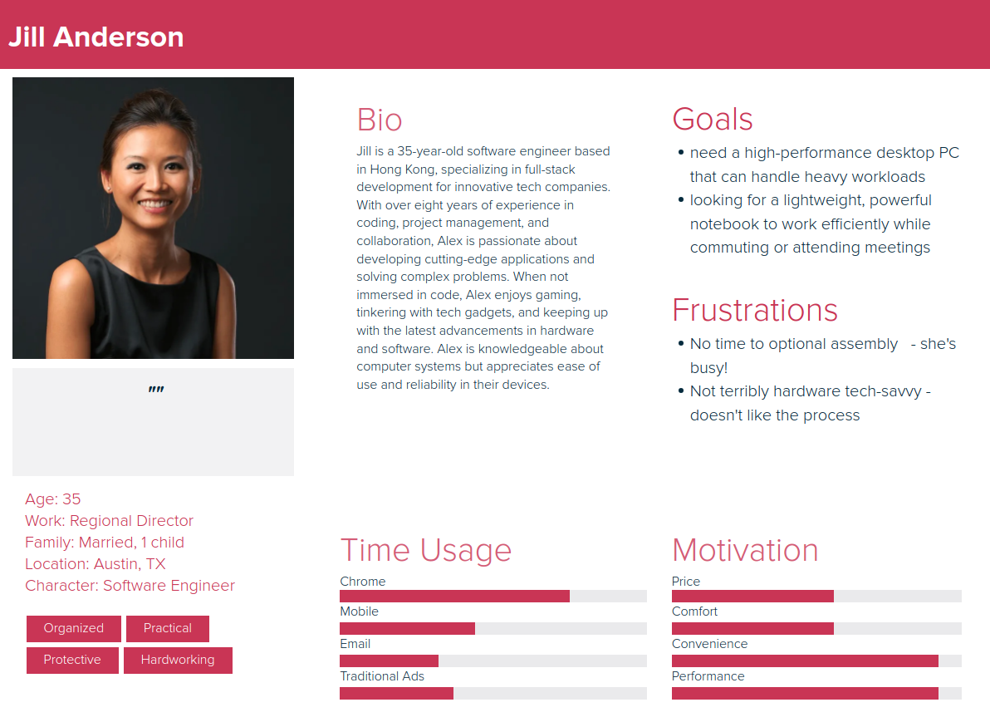

# 4 Design principles

Why need to use design principles? Design principles are foundation guidelines for designing intuitive, efficient, and user-friendly interfaces. By applying those, designers will make sure that the website meets users' expectations, spends little cognitive load, and enhances usability. The redesign of Buymore.hk used fundamental design principles from both basic interaction design and Bruce Tognazzini’s First Principles of Interaction Design (Tognazzini, 2014). that would improve the navigation, accessibility, and satisfaction of the users.

# 4.1 Visibility

One principle of visibility is that it should be apparent to the users what the main functions or navigation elements are-the critical features in the original Buymore.hk design like the "Getting Started" guide were buried down at the bottom of the pages, and this unclear interface element which looked like the ">>>" price filter button has caused a lot of confusion to many users. The enhancement of visibility is done by taking important guides and putting them on noticeable areas of the navigation bar instead of using ambiguous icons that can be replaced with intuitive controls. The user becomes guided visual hierarchies plus strategically placed white spaces further assume directing user attention to events of importance-in effect making the interface scannable while reducing cognitive load during navigation.

# 4.2 Affordance

Affordance principles guide our redesign to make interactive elements self-evident. Original site affordance was terrible because of non-labelled icons and drop-down menus that did not provide visual hints suggesting interactivity. We replaced cryptic icons with text-labelled buttons like "Grid View” and then introduced efficient clear visual cues hover effects and dropdown arrows to increase affordance. These changes enable users to recognize clickable items on sight and learn how to interact with different interface components on-site without any prior knowledge or instruction.

# 4.3 Feedback

The previous interface did not adequately respond to the basic system responses as it had done; we have taken the review a step further to verify the steps for high-stakes interactions. Presently purchase confirmations feature prominently in modal dialogs that allow further explicit approval by the user before any payment processing is done. Initiating the submission of any form will create a well-defined success notification it can be a reference number for scrutiny. The new layers of confirmations act as critical stopovers, especially for monetary transactions and data submissions.

# 4.4 Constraint

Thoughtful constraints prevent user errors while streamlining the process; the original site was opened to contradictory selections such as various types of cooling devices used with the CPU or multiline forms input without restrictions. Intelligent constraints in our redesign include exclusive options in selection input length indicators and unambiguous warning messages. They lead users to valid choices yet retain flexibility. In preventing upfront impossible or problematic configurations, we also reduce wasting time with frustration and needing to take corrective actions, thus streamlining the whole purchasing process.

# 4.5 Consistency

Consistency is setting up patterns predictable so that the cognitive load could be less. In the original interface, there were inconsistent button styles, varying menu structures, and irregular use of layout conventions. The redesign has made the components maintain a common visual language, standardized the interaction patterns, and coherent information architecture. Thus, common actions are now found in similar places and with the same styling so that a user would be able to transfer knowledge from one area of the site to another. This organized approach gives a much more professional appearance and, at the same time, creates a significant improvement in the ease and efficiency of learnability and navigation.

# 4.6 Efficiency of the user (Tognazzini's Principle)

Efficiency deals with the internal routing of elements to produce an optimum course of action where no unnecessary actions pop up. The design had too many clicks for filtering by price, as well as a lack of keyboard navigation support. One-click filtering controls, keyboard shortcuts, and streamlined processes that shorten the interaction cost have been introduced by the redesign. The design knocks off unnecessary steps from the process while providing multiple interaction methods to Favor both beginner and expert users. These efficiency improvements will make a faster accomplishment of goals as well as reduce fatigue in long-distance browsing.

# 5 Prototype

# 5.1 Screen description and Screen flow

**Original Design**



**After Redesign**

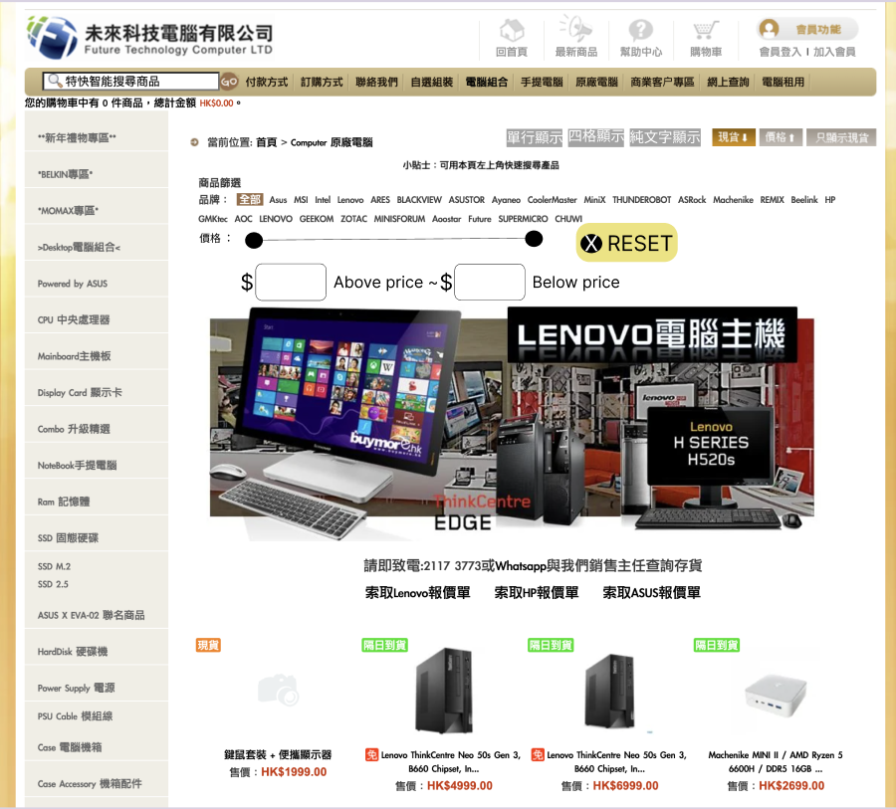

This screen is the screen for the user to purchase the whole computer. Comparison between old and new designs, the old design categorizing methods linking subpages in the same category are repetitive, such as listing the pricing ranges by every 300 intervals from 0 to 6000 until the “>>>” button. The “>>>” button means filtering above 6000 price. But the user may not know the button's meaning since it does not have a good illustration. Some unmeaningful icon buttons on the top right are doing different display methods. After redesigning, it can see the button of each range 300 price is changed to enter the price. Having rolling bars to control or select the above price and below price. That improves product filtering efficiency. Having the reset button. The user is more comfortable filtering the price again. Also put the tips on the top and center. So, the user would easily find the search function position. On the other hand, changing the unmeaningful icon buttons to text buttons. Users would be more aware of the function. Also, using text buttons in order to maintain consistency and aesthetics.

**Original Design**



**After Redesign**

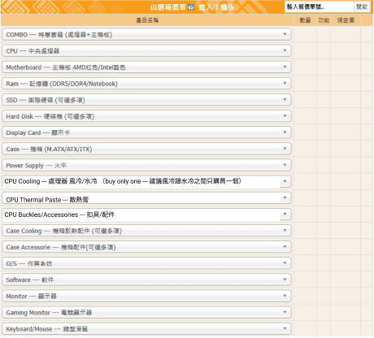

This screen is the screen for the user to purchase the computer Component such as CPU, ram, display card. Comparison between old and new designs, the old design has a lot of CPU Cooling dropdown menu and too many components in one dropdown menu. It may make users confused, and it is hard to find out what they want. Therefore, after redesigning, it can see the component is separated into three parts. They are CPU Cooling, CPU Thermal Paste and CPU Buckles/Accessories. The user would be quicker to find out what they want. Also reminding users to buy one CPU cooling between air cooling and water cooling to prevent customers buying more.

**Original Design**



**After Redesign**

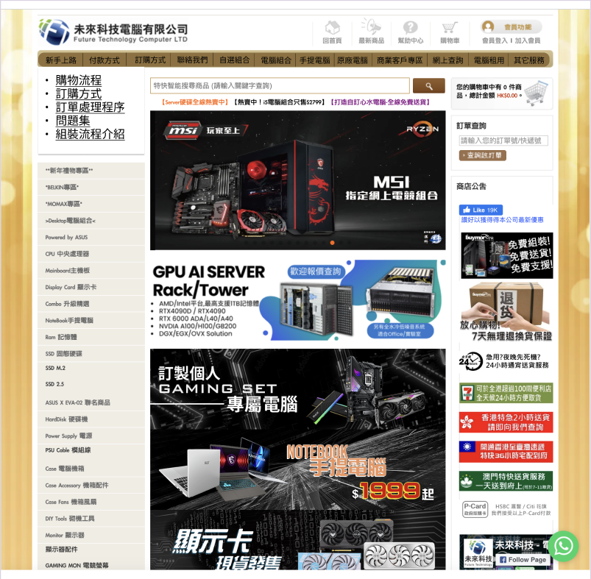

This screen is the home page. It can do a lot of things. In the old design, the "Getting Started(新手上路)" button in the bottom of home page. Customers may not find out the user guide. But the help and documentation are important. In the new design, it can see the "Getting Started" button in the Top of the bar. When clicking the "Getting Started" button will display a lot of help and documentation. Users would conveniently receive the guide. The user would more easily understand the flow. Also, the bar adds the other service button to navigate to the bottom to watch service.

**Original Design**



**After Redesign**

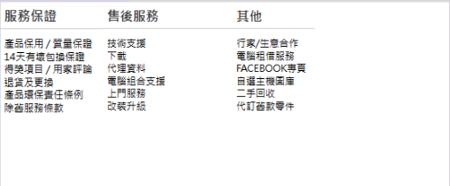

After Redesign, it just displays the service and others since the other function is repeated. The website should maintain an aesthetic and minimalist design. It reduces users' absorption of useless information.

**Original Design**

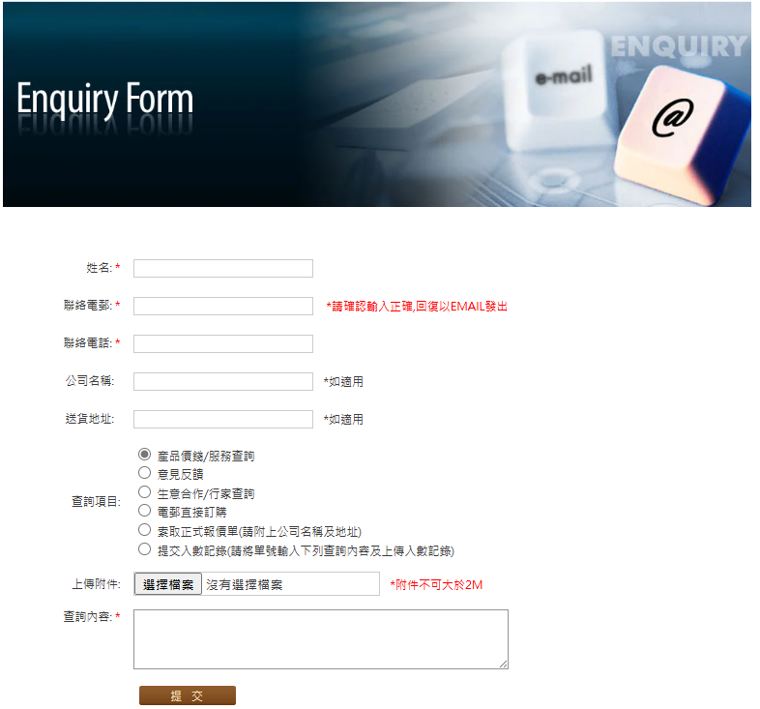

**After Redesign**

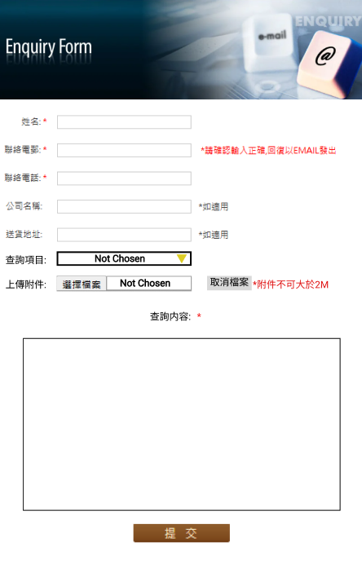

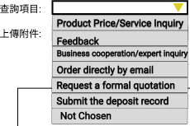

In the original design, the Query Item and Upload attachments did not have the cancel control for users to reset the Query Item choice to space and go back to no file chosen. The input box of Query Content is too small. All the lack needs to transform. After redesigning, the Query Item uses a dropdown menu

to make the user select one choice and add a “Not Chosen” choice provided to the customer. Therefore, users can choose to do nothing. Upload attachments have the same meaning. Giving the cancel file button to delete the file. Users would feel more flexible. To avoid the user entering all the information again since the user cannot go back to no file chosen, the user may refresh the page. Also, the Query Content should be larger. Users have more space to enter questions or feedback.

**Original Design**

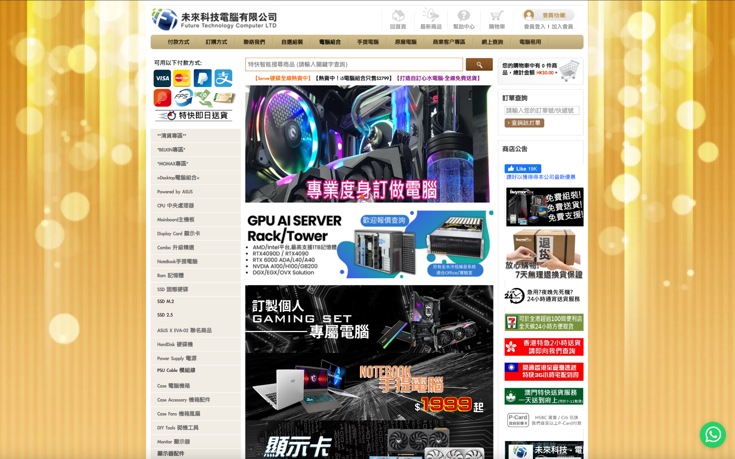

**After redesign**

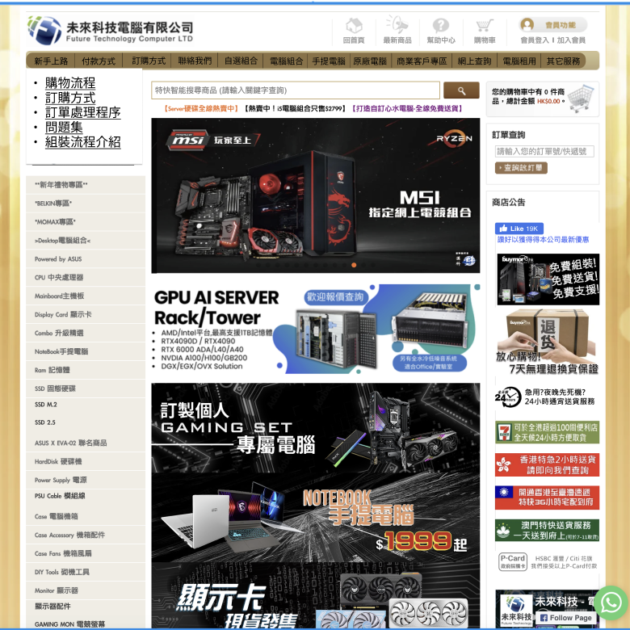

In the original design you can see the yellow color background on the left and right side. After redesigning, it should cut a lot of background since there is not any information for users to look at. At the same time, cutting the background would have more space. So, the content of any button, promotion or information can be bigger. It improves users' watching more focus and clear.

**Original Design**



**After redesign**

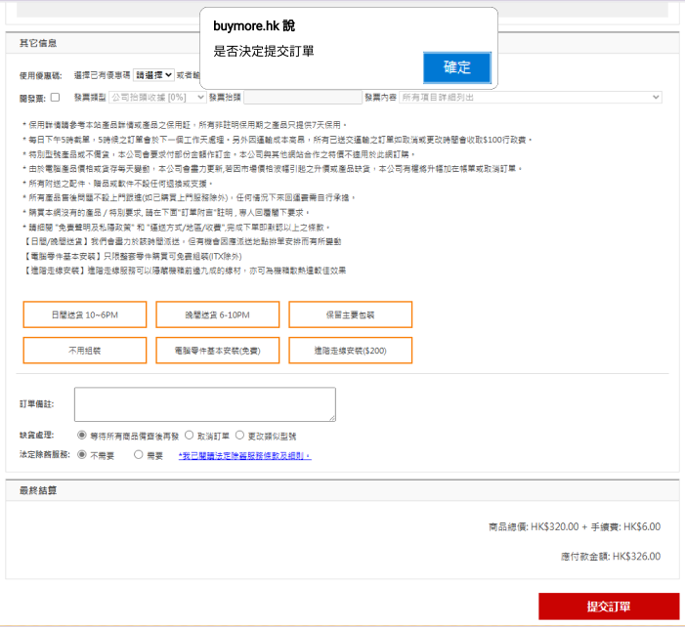

On the after redesign, it should add confirm alert to remind or prevent user mistakenly clicking the submit button. Also, users can check the personal or product information again to confirm customers are entering the right thing.

# 5.2 Prototype link

**Prototype Link:**

<https://www.figma.com/proto/BVsGSch4SLgScYdiBKOZNa/Lab1--Copy-?node-id=33-444&t=e0NwaJzdwwlkNS04-1>

**Dev Mode Link:**

<https://www.figma.com/design/BVsGSch4SLgScYdiBKOZNa/6002-Design?node-id=33-444&m=dev&t=e0NwaJzdwwlkNS04-1>

# 5.3 Demonstration

<https://drive.google.com/file/d/1ljdVcO1hysVcYUssDuEDc-QvGSy3Jc2i/view?usp=sharing>

# 6 User evaluation

# 6.1 Ethical consideration

The survey shall be done with considerable respect for its participants; ethical guidelines shall be applied to protect participants' rights, safety, and privacy.

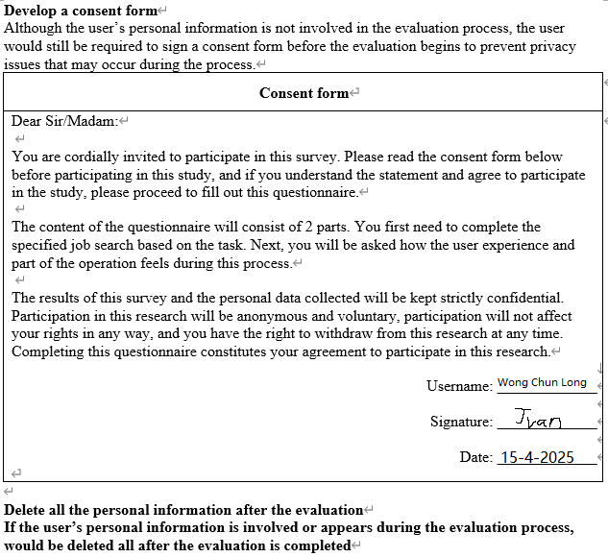

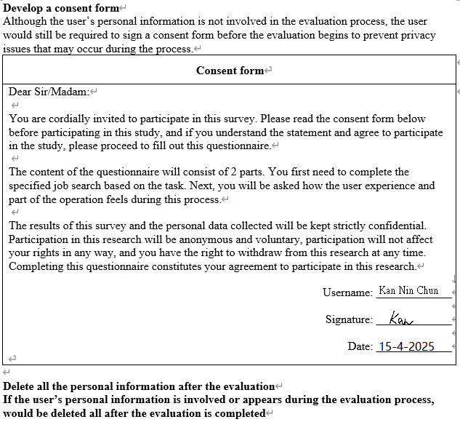

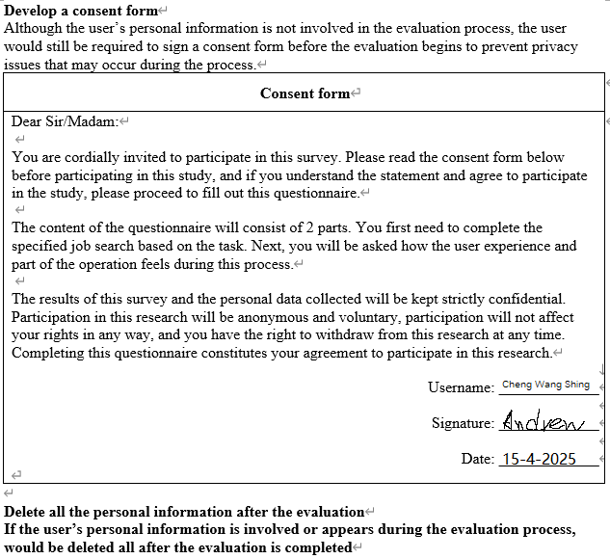

# 6.2 Practical consideration

For evaluating the users, test participants representing the core customer base of Buymore.hk were carefully selected. The focus here was recruiting users intending to purchase computer hardware while having some familiarity with technical terms. Such criteria would ensure that participants could give meaningful feedback with respect to real-world shopping experiences on the redesign platform.

pre-test questionnaire:

Familiar with technical terms like CPU, GPU, RAM, and SSD. Also, experience with online shopping platforms, have used at least three online shopping platforms.

# 6.3 Testing arrangement / method

original page

* See the attached link:

<http://buymore.hk>

redesign page

* See the attached link:

<https://www.figma.com/proto/BVsGSch4SLgScYdiBKOZNa/Lab1--Copy-?node-id=33-444&t=e0NwaJzdwwlkNS04-1>

Test steps:

Enter the original page to do the below test. After tester complete the test, it would give the questionnaire to tester to answer. Then enter the redesign page to do the below test and give the questionnaire again. To find out the difference between original and redesign.

1. Locate the "Getting Started" guide and review the purchasing process guide

2. Find a gaming laptop under HK$8,000 using the price filter

3. Configure a PC, at least with the CPU, Motherboard, Ram, SSD, Hard Disk, Display Card, Case, Power Supply, CPU Cooling

4. Submit an enquiry tester wants to ask. If nothing wants to ask, tester can submit a price or discount enquiry

5. Complete the checkout process for a selected item

# 6.4 Result

Question for each step: Were you able to successfully complete each task? (Answering Yes or No) Are key functions immediately visible and convenient? (Explain)

Tester 1:  
Original Website:

1. No, the guide was buried in an unintuitive menu structure
2. Yes, but filter controls were inefficient.
3. No, selected incompatible components by accident
4. Yes, the submission worked, there was an immediate confirmation message
5. Yes, but there was no confirmation or prevention when the tester accidentally clicked submit.

Redesigned Website:

1. Yes, found it immediately in the top navigation
2. Yes, sliders and entering filters make filtering very easy
3. Yes, the separated categories prevented mistakes
4. Yes, it has a bigger and Clear query content box
5. Yes, it would appear the confirm alert to avoid accidentally clicking submit when I submit

Tester 2:  
Original Website:

1. Yes, but only after extensive searching
2. Yes, but filter controls were inefficient
3. Yes, but it made two configuration errors
4. Yes, standard submission process
5. Yes, though steps felt repetitive

Redesigned Website:

1. Yes, prominent position saved time
2. Yes, precise price control worked well
3. Yes, it is more streamlined than the original
4. Yes, standard submission process, Also I know that query item can do not chosen
5. Yes, warning messages help avoid mistakes

Tester 3 :  
Original Website:

1. No, wasn't where expected
2. Yes, but filter lacked precision
3. Yes, though the interface was cluttered
4. Yes, basic but functional
5. Yes, familiar e-commerce pattern

Redesigned Website:

1. Yes, logical placement in main nav
2. Yes, the exact price input was superior
3. Yes, component organization was optimal
4. Yes, having more control
5. Yes, familiar e-commerce pattern. Also, the tester can find the purchasing process guide, so make the checkout process more clear

**Analysis:**

The revamped site was much improved in terms of usability with key functionality (i.e., navigation, filters, prevention of errors) promoted and obvious. Testers completed tasks in less time with reduced errors, reaffirming that tidy designs, readable feedback, and consistent work flows enhance end-user experience over early messy design.

# Reference

[Tognazzini, B. (2014, December 18). *First Principles of Interaction Design (Revised & Expanded)*. askTog. https://asktog.com/atc/principles-of-interaction-design/](Tognazzini,%20B.%20(2014,%20December%2018).%20First%20Principles%20of%20Interaction%20Design%20(Revised%20&%20Expanded).%20askTog.%20https:/asktog.com/atc/principles-of-interaction-design/)